Lab2 TNM098 – Eye Tracking

*Jens Jakobsson and Jonathan Bosson*

**Introduction**

The task was to analyze a data file containing eye tracking data over time. It had the following dimensions:

1. A timestamp for the event.
2. A fixation index which is just an order in the file.
3. The event duration in milliseconds.
4. A gaze point index (which is pretty meaningless).
5. X coordinate of gaze point in pixels.
6. Y coordinate of gaze point in pixels

**Method**

The group used matlab to implement an animation over time and the inbuilt clustering function kmeans to cluster the data in both spatial and duration domain.

By animating the data the movement of the eyes could be visualized. This gave insight in how the gaze shifted throughout time.

**Result**

Figure 1 displays all the data points clustered depending on their duration spent. The blue color are the points where the gaze spent very little time while the red color is where a lot of time was spent while the green color represents an in between value. We can then see that the top and bottom left corners as well as the top right corner were the areas that took most of the attention, since there is a high density of red values there.

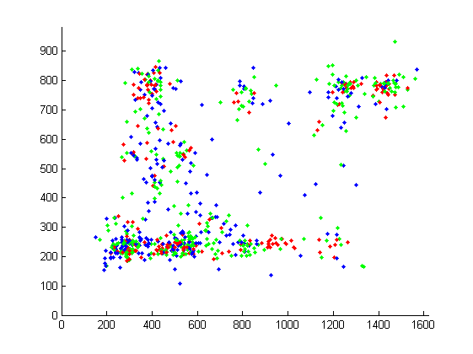

Figur 1: Cluster over duration

Figure 2 is divided into five clusters depending on the spatial position of the data.

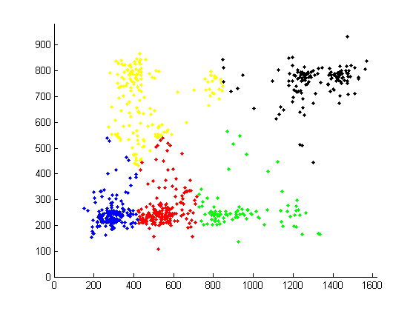

Figur 2: Cluster over position

The figures below illustrates the animation over time (left to right). We can see that in the beginning the gaze is fixed on the bottom left area. The second figure shows how after some time the user makes an overview of the screen. The third picture shows that the yellow area gets more attention (higher density). The last picture shows that the red, blue and black clusters are given more attention as the density in these areas increases.

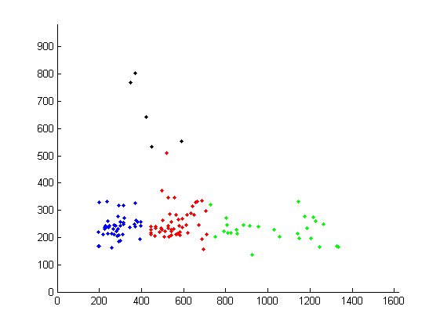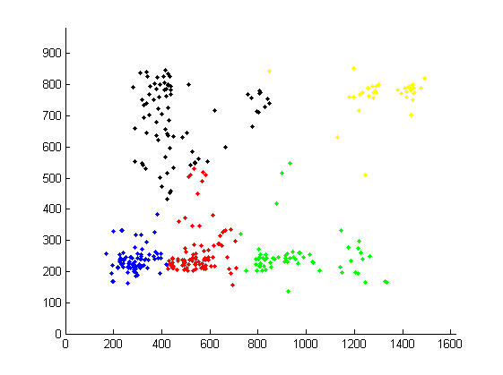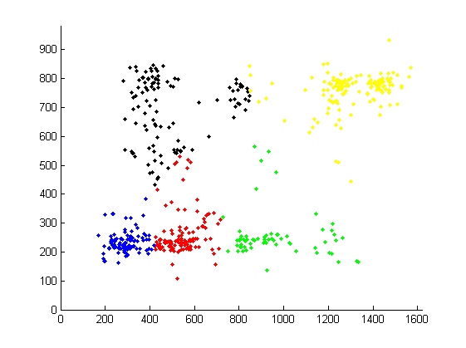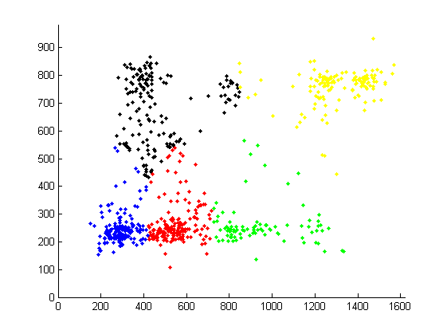

**Discussion**

A higher number of cluster for the duration clustering would cause more confusion since it becomes increasingly difficult to determine what each color means.

More clusters on the position figure would debatably render a better result, although inspecting the plot shows two separate regions with a high density of points in the bottom left corner and top right corner.